1. Create a new React Application with the name “myfirstreact”, Run the application to print “welcome to the first session of React” as heading of that page.
2. To create a new React app, Install Nodejs and Npm from the following link:

<https://nodejs.org/en/download/>

1. Install Create-react-app by running the following command in the command prompt:

https://lh7-rt.googleusercontent.com/docsz/AD_4nXfAvZ5xfGmlgCSwOk57uuUcWPk3iFH-TZk8EBArdHV-RALX4xpZXm1yVCKyLOyM-KPt1gHHMNbREYDHPJKc4i16wsuKFu6RcWzBfeakG5KXD9g4jMoAwZ8SmIVhUeCQaJA3h6wR__kzRlL6JrympDc?key=7wg7URBFaH91rv2VFJe56g

1. To create a React Application with the name of “myfirstreact”, type the following command:

https://lh7-rt.googleusercontent.com/docsz/AD_4nXfxKGqelob2_vV3fHa9XvOPU1GXG0Reyc1kzRUamRPw5Y3MFJyYuFP1UE6sYxBi4_HV8Lz8ZSVI6MQCii7crHiLB2qDxo0bBctPp8HaZXCt1BeQtACMosmKUZQkMs7rim4X3AAB2Hmc5CzSriRRpA8?key=7wg7URBFaH91rv2VFJe56g

1. Once the App is created, navigate into the folder of myfirstreact by typing the following command:

https://lh7-rt.googleusercontent.com/docsz/AD_4nXcodjF96uuNm86IDFXD14gCubN3bqUkCpBaRdZZVD1j9hDh-lrtNl0ULQBlVXtxNsDhQ5jJclAakYmx_YO713JIjjeuHoTaaQgMaH61omZ3NNDmV9nX8Yzgwd_VUOaUmen02kpqWdhpH61B58coFw?key=7wg7URBFaH91rv2VFJe56g

1. Open the folder of myfirstreact in Visual Studio Code
2. Open the App.js file in Src Folder of myfirstreact
3. Remove the current content of “App.js”
4. Replace it with the following:

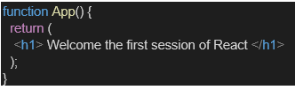

1. Run the following command to execute the React application:

https://lh7-rt.googleusercontent.com/docsz/AD_4nXc74XnvtmTvrpINHdNTyEWKzN5eYBfSMqJgRr7515v7EkFZy5XphcDQQLpUGWshRWzbvgz_0MZLTJ7UuCV1hPQKndVK1po_SCz-PuEq5rgDfWm546u3Ac2vE0cdQ29S-x_hinTGZzwkVsP79MxCdQ?key=7wg7URBFaH91rv2VFJe56g

1. Open a new browser window and type “localhost:3000” in the address bar

App.js:

import React from 'react';

function App() {

  return (

    <div className="App">

      <h1>Welcome to the first session of React</h1>

    </div>

  );

}

export default App;

web Screenshot:

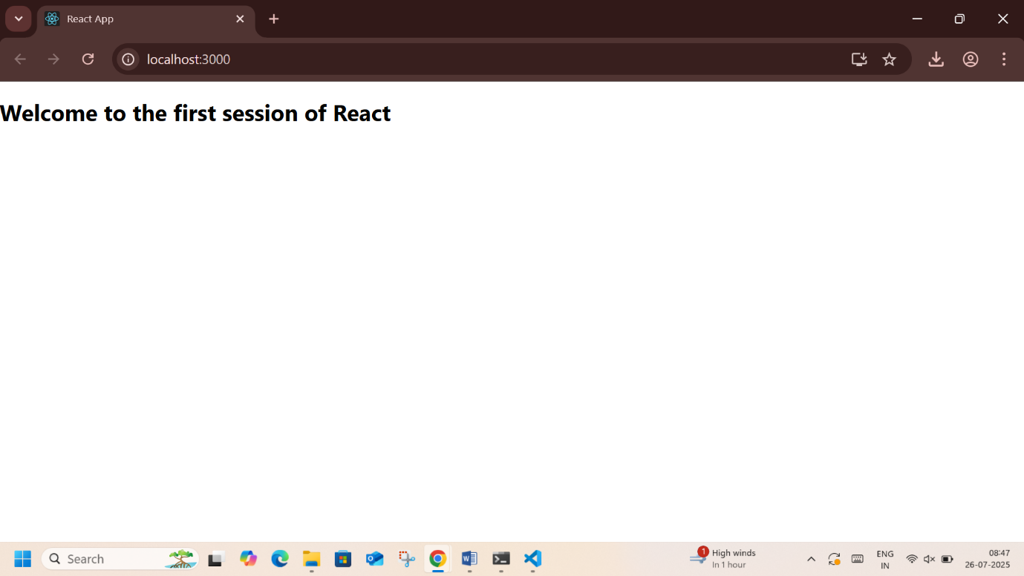

1. Create a react app for Student Management Portal named StudentApp and create a component named Home which will display the Message “Welcome to the Home page of Student Management Portal”. Create another component named About and display the Message “Welcome to the About page of the Student Management Portal”. Create a third component named Contact and display the Message “Welcome to the Contact page of the Student Management Portal”. Call all the three components.

1. Create a React project named “StudentApp” type the following command in terminal of Visual studio:

https://lh7-rt.googleusercontent.com/docsz/AD_4nXdzollHuUG73jATx7S0Iioxg-RXb-meL_B8LmmssuGBL4WEXzg3VO0Vn8Lkonm7YzzO4SqExHY-WM3juDYAOnlT7bWxL1KTvgPrlv_WSVHS_JPHrBxGhuDBUaNw1cGj8D98cV_bYMy2sipv7gtGDQ?key=if7wT92JNL3yk2cPKZBT8Q

1. Create a new folder under Src folder with the name “Components”. Add a new file named “Home.js”

1. Type the following code in Home.js

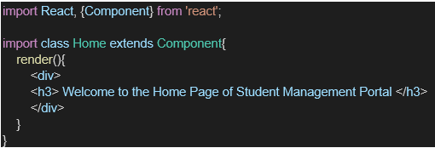

1. Under Src folder add another file named “About.js”

1. Repeat the same steps for Creating “About” and  “Contact” component by adding a new file as ”About.js”, “Contact.js” under “Src” folder and edit the code as mentioned for “Home” Component.

1. Edit the App.js to invoke the Home, About and Contact component as follows:

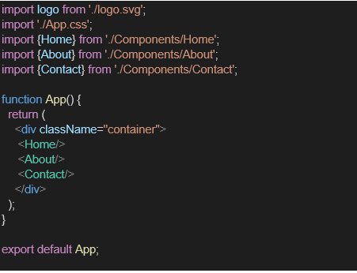

1. In command Prompt, navigate into StudentApp and execute the code by typing the following command:

https://lh7-rt.googleusercontent.com/docsz/AD_4nXcdwkNV-RClIgaR9yGprUwoC0kYbfBEpZ8xWdq6G7SzwzuTZfKdGJum3KBzvHlhOIlPS4jjb6rol_JIt47V776wSdUN5sIQYp7gj1K0g8vrST9OyPGcduqJE0tLWPfr4smTsQ_hYaqDY10mQeCVAI8?key=if7wT92JNL3yk2cPKZBT8Q

1. Open browser and type “localhost:3000” in the address bar:

Home.js:

 import React from 'react';

 class Home extends React.Component {

      render() {

        return <h1>Welcome to the Home page of Student Management Portal</h1>;

      }

    }

    export default Home;

About.js:

import React from 'react';

class About extends React.Component {

      render() {

        return <h1>Welcome to the About page of the Student Management Portal</h1>;

      }

    }

    export default About;

Contact.js:

import React from 'react';

class Contact extends React.Component {

      render() {

        return <h1>Welcome to the Contact page of the Student Management Portal</h1>;

      }

    }

    export default Contact;

App.js:

import React from 'react';

import Home from './components/Home';

import About from './components/About';

import Contact from './components/Contact';

import './App.css';

function App() {

      return (

        <div className="App">

          <Home />

          <About />

          <Contact />

        </div>

      );

    }

    export default App;

Web Screenshot:

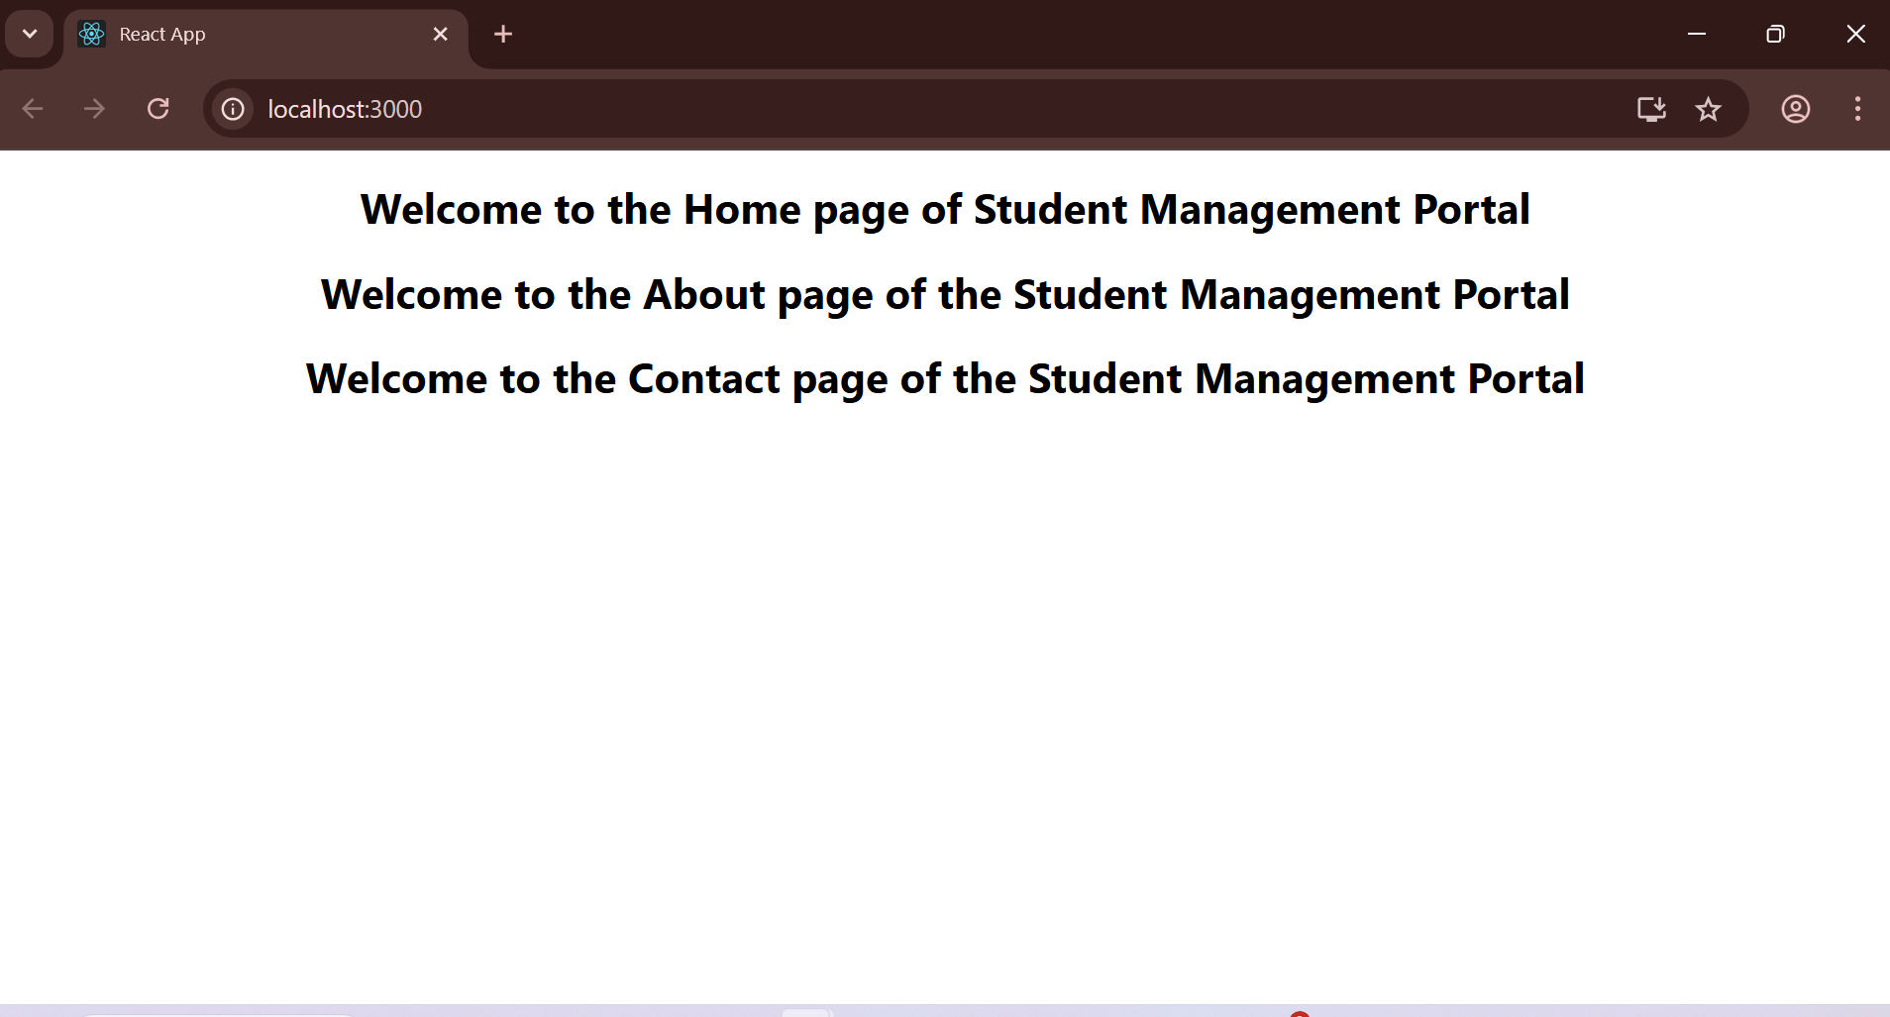

1. Create a react app for Student Management Portal named scorecalculatorapp and create a function component named “CalculateScore” which will accept Name, School, Total and goal in order to calculate the average score of a student and display the same.

1. Create a React project named “scorecalculatorapp” type the following command in terminal of Visual studio:

https://lh7-rt.googleusercontent.com/docsz/AD_4nXfD9Fly2kZeI26V3NC2dm628VZ988NIsuWJ0qsfA8vUoKhfw5AJ1g9oT3RiXPeRZdpGygCexPZnwAUR9QupFJEG1FPHvBP0BB3w7UWmsdJ_WDzyIuoVHNwf8KuU1LHcM5Hl2JBSqzMI-fuT9YyTr3w?key=5yWJEY-7d6q_LEfrRAFl2w

1. Create a new folder under Src folder with the name “Components”. Add a new file named “CalculateScore.js”

1. Type the following code in CalculateScore.js

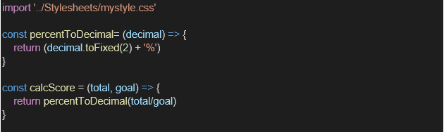

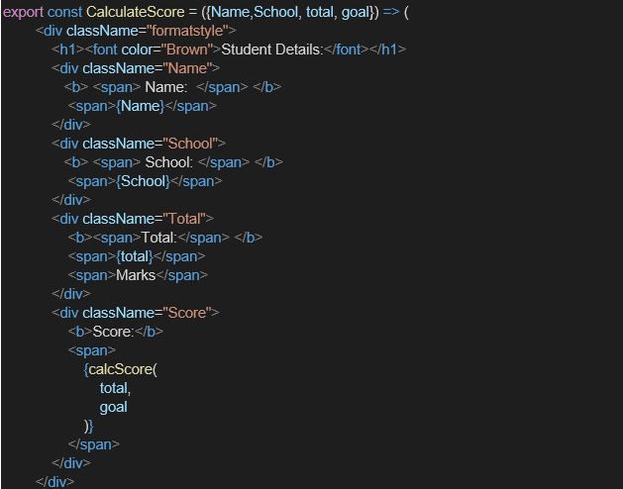

1. Create a Folder named Stylesheets and add a file named “mystyle.css” in order to add some styles to the components:

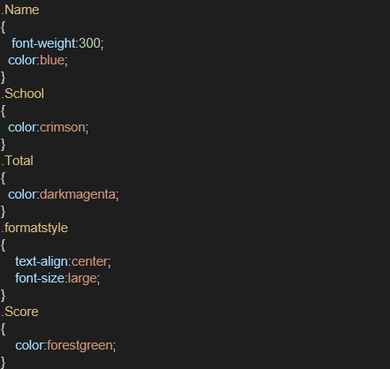

1. Edit the App.js to invoke the CalculateScore functional component as follows:

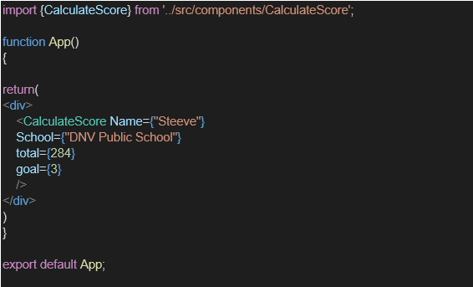

1. In command Prompt, navigate into scorecalculatorapp and execute the code by typing the following command:

https://lh7-rt.googleusercontent.com/docsz/AD_4nXch-Z73XJg8TVLL2hO9XEVKRXGHqZEJDgdPjPkwrJp_BAS_j5EUjSgtDYMwpAYUD8SkhVv9-kK02D0umBy1FVqMyEYqLFz_ZC1X8WLlr2e7l0vHEchRHGZkOc6KzjISg8EyxXRFNyihGniSX0YteQ?key=5yWJEY-7d6q_LEfrRAFl2w

1. Open browser and type “localhost:3000” in the address bar:

CalculateScore.js:

import React from 'react';

import './../Stylesheets/mystyle.css';

function CalculateScore(props) {

  const { Name, School, Total, Goal } = props;

  const averageScore = Total / 3;

  const isGoalAchieved = averageScore >= Goal;

  const scoreStyle = {

    color: isGoalAchieved ? 'green' : 'red',

    fontWeight: 'bold'

  };

  return (

    <div className="student-card">

      <h2>Student Details</h2>

      <p><strong>Name:</strong> {Name}</p>

      <p><strong>School:</strong> {School}</p>

      <p><strong>Total Marks:</strong> {Total}</p>

      <p><strong>Goal:</strong> {Goal}</p>

      <p><strong>Average Score:</strong> <span style={scoreStyle}>{averageScore.toFixed(2)}</span></p>

      <p>{isGoalAchieved ? 'Goal Achieved!' : 'Goal Not Achieved.'}</p>

    </div>

  );

}

export default CalculateScore;

mystyle.css:

body {

  font-family: Arial, sans-serif;

  background-color: #f4f4f4;

  margin: 0;

  padding: 20px;

  display: flex;

  justify-content: center;

  align-items: flex-start;

  min-height: 100vh;

}

.student-card {

  background-color: #ffffff;

  border-radius: 8px;

  box-shadow: 0 2px 4px rgba(0, 0, 0, 0.1);

  padding: 25px;

  margin: 15px;

  width: 300px;

  box-sizing: border-box;

  text-align: left;

}

.student-card h2 {

  color: #333;

  border-bottom: 2px solid #eee;

  padding-bottom: 10px;

  margin-bottom: 15px;

}

.student-card p {

  margin-bottom: 8px;

  color: #555;

}

.student-card p strong {

  color: #333;

}

.App {

  text-align: center;

  margin-top: 20px;

}

.App-header {

  background-color: #282c34;

  padding: 20px;

  color: white;

  margin-bottom: 30px;

  border-radius: 8px;

}

.App-header h1 {

  margin: 0;

  font-size: 2.5em;

}

App.js:

import React from 'react';

import CalculateScore from './components/CalculateScore';

import './App.css';

function App() {

  return (

    <div className="App">

      <header className="App-header">

        <h1>Student Management Portal</h1>

      </header>

      <div className="student-cards-container">

        <CalculateScore Name="Steeve" School="DNV Public School" Total={284} Goal={95} />

      </div>

    </div>

  );

}

export default App;

Web Screenshot:

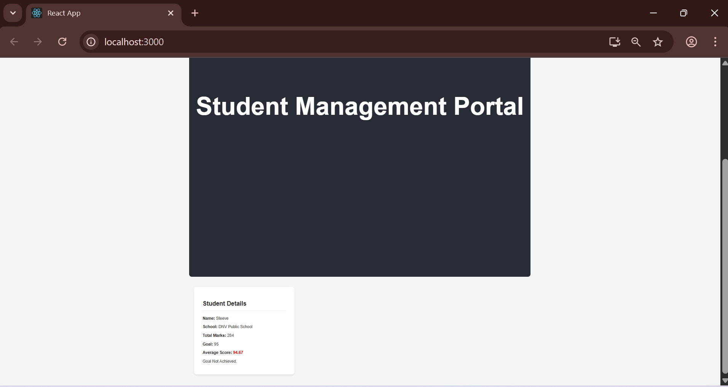

1. Create a new react application using *create-react-app* tool with the name as “blogapp”
2. Open the application using VS Code
3. Create a new file named as **Post.js** in **src folder** with following properties

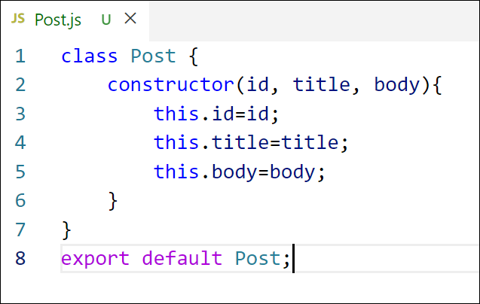

*Figure 2: Post class*

1. Create a new class based component named as **Posts** inside **Posts.js** file

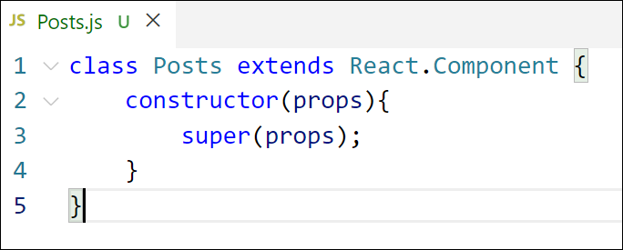

*Figure 3: Posts Component*

1. Initialize the component with a list of Post in state of the component using the constructor
2. Create a new method in component with the name as **loadPosts()** which will be responsible for using Fetch API and assign it to the component state created earlier. To get the posts use the url  (<https://jsonplaceholder.typicode.com/posts>)

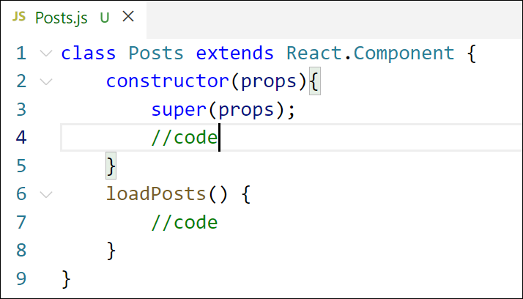

*Figure 4: loadPosts() method*

1. Implement the **componentDidMount()** hook to make calls to **loadPosts()** which will fetch the posts

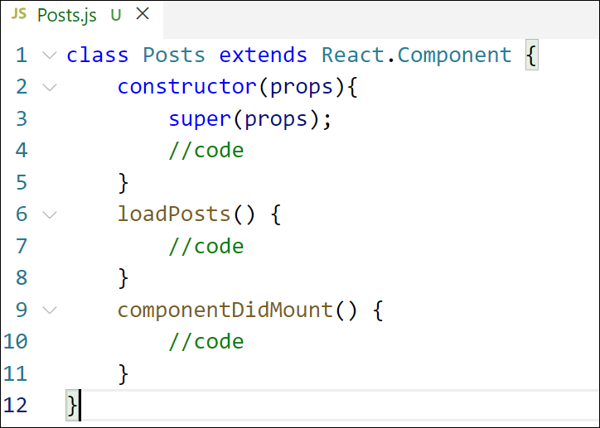

*Figure 5: componentDidMount() hook*

1. Implement the **render()** which will display the title and post of posts in html page using heading and paragraphs respectively.

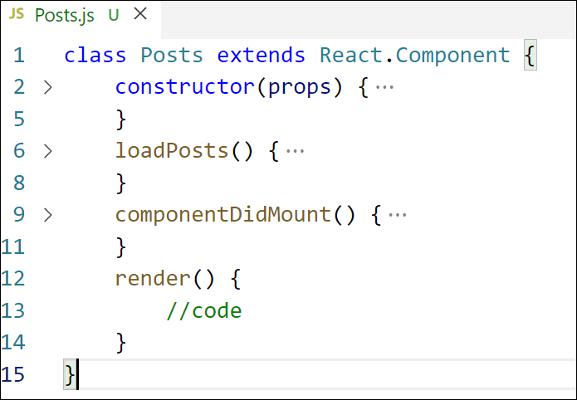

*Figure 6: render() method*

1. Define a **componentDidCatch()** method which will be responsible for displaying any error happing in the component as alert messages.

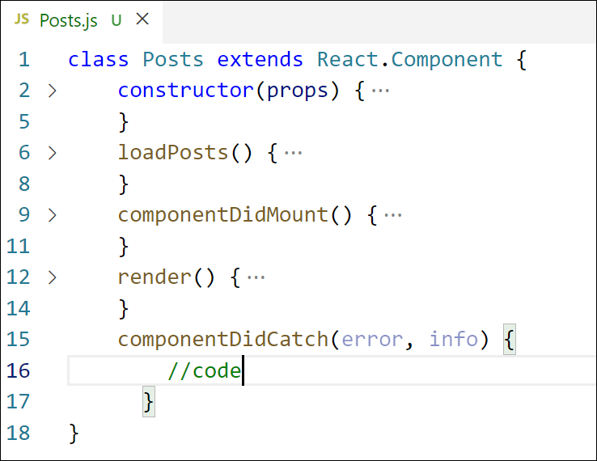

*Figure 7: componentDidCatch() hook*

1. Add the Posts component to App component.
2. Build and Run the application using *npm start* command.

Post.js:

class Post {

  constructor(id, title, body){

    this.id=id;

    this.title=title;

    this.body=body;

  }

}

export default Post;

Posts.js:

import React from 'react';

import Post from './Post';

class Posts extends React.Component {

  constructor(props){

    super(props);

    this.state = {

      posts: []

    };

  }

  async loadPosts() {

    try {

      const response = await fetch('https://jsonplaceholder.typicode.com/posts');

      if (!response.ok) {

        throw new Error(`HTTP error! status: ${response.status}`);

      }

      const data = await response.json();

      const loadedPosts = data.map(item => new Post(item.id, item.title, item.body));

      this.setState({ posts: loadedPosts });

    } catch (error) {

      console.error("Error fetching posts:", error);

    }

  }

   componentDidMount() {

    this.loadPosts();

  }

  componentDidCatch(error, errorInfo) {

    this.setState({

      hasError: true,

      error: error,

      errorInfo: errorInfo

    });

    console.error("Error caught by componentDidCatch:", error, errorInfo);

    alert(`An error occurred: ${error.toString()}\nComponent Stack: ${errorInfo.componentStack}`);

  }

  render() {

    if (this.state.hasError) {

      return <h1>Something went wrong.</h1>;

    }

    const { posts } = this.state;

    return (

      <div>

        <h1>Posts</h1>

        {posts.length > 0 ? (

          posts.map(post => (

            <div key={post.id}>

              <h2>{post.title}</h2>

              <p>{post.body}</p>

            </div>

          ))

        ) : (

          <p>Loading posts...</p>

        )}

      </div>

    );

  }

}

export default Posts;

App.js:

import React from 'react';

import './App.css';

import Posts from './Posts';

function App() {

  return (

    <div className="App">

      <header className="App-header">

        {}

      </header>

      <main>

        <Posts /> {}

      </main>

    </div>

  );

}

export default App;

Web Screenshot:

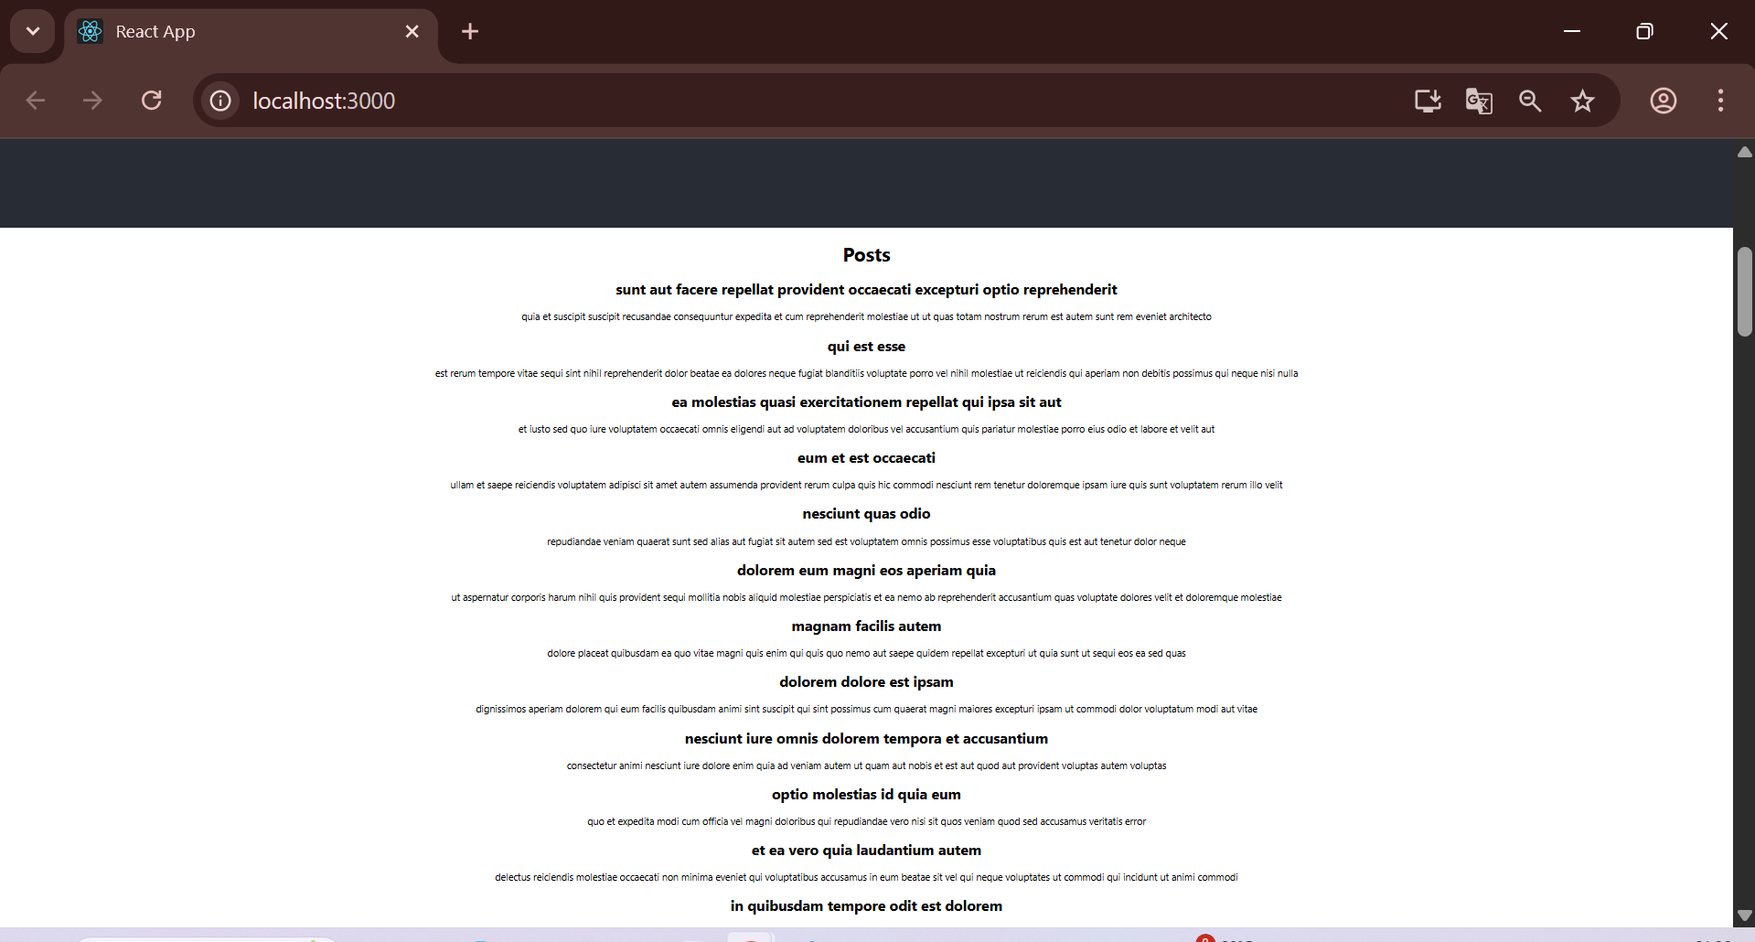

CohortDetailModule.css:

.box {

  width: 300px;

  display: inline-block;

  margin: 10px;

  padding: 10px 20px;

  border: 1px solid black;

  border-radius: 10px;

}

dt {

  font-weight: 500;

}

CohortDetails.js:

import React from 'react';

import styles from './CohortDetails.module.css';

function CohortDetails({ cohort }) {

  const titleStyle = {

    color: cohort.status === 'ongoing' ? 'green' : 'blue',

  };

  return (

    <div className={styles.box}>

      <h3 style={titleStyle}>{cohort.name}</h3>

      <dl>

        <dt>Start Date:</dt>

        <dd>{cohort.startDate}</dd>

        <dt>End Date:</dt>

        <dd>{cohort.endDate}</dd>

        <dt>Status:</dt>

        <dd>{cohort.status}</dd>

      </dl>

    </div>

  );

}

export default CohortDetails;

App.js:

import React from 'react';

import CohortDetails from './Cohorts/CohortDetails';

function App() {

  const cohorts = [

    {

      name: 'React Bootcamp',

      startDate: '2025-07-01',

      endDate: '2025-08-01',

      status: 'ongoing',

    },

    {

      name: 'Python Basics',

      startDate: '2025-06-01',

      endDate: '2025-06-30',

      status: 'completed',

    },

  ];

  return (

    <div className="App">

      <h2>My Academy Dashboard</h2>

      {cohorts.map((cohort, index) => (

        <CohortDetails key={index} cohort={cohort} />

      ))}

    </div>

  );

}

export default App;

Web Screenshot:

